1. Write a C++ program to create a class Person that has private data member name, age, country. Implement member function to get and set values for the variable.

Program :

#include<iostream>

#include<string>

using namespace std;

class Person {

string name;

int age;

string country;

public:

void get()

{

cout << "Enter your name : ";

cin >> name;

cout << "Enter your age : " << endl;

cin >> age;

cout << "Enter your country : " << endl;

cin >> country;

}

void set()

{

cout << "\nPerson Details : " << endl;

cout << "Name : " << name << "\nAge : " << age << "\nCountry : " << country;

}

};

int main()

{

Person person;

person.get();

person.set();

return 0;

}

Output :

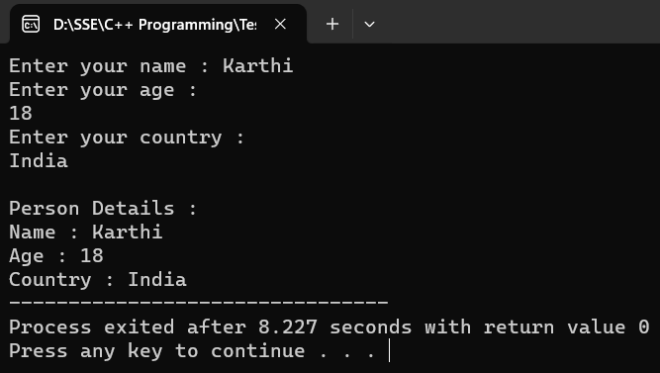

1. Create a class named Rectangle with two data members length and breadth and function to calculate area. The class has 3 constructor (having no parameter,having 2 nos as parameter,having one number as parameter).

Program :

#include<iostream>

using namespace std;

class Rectangle {

public:

double length, breadth;

Rectangle() {

length = 0;

breadth = 0;

}

Rectangle(double x, double y) {

length = x;

breadth = y;

}

Rectangle(double x) {

length = x;

breadth = x;

}

double Area() {

return length * breadth;

}

};

int main() {

Rectangle rect1;

double a, b;

cout << "Enter length and breadth for rect2: ";

cin >> a >> b;

Rectangle rect2(a, b);

double c;

cout << "Enter side for rect3: ";

cin >> c;

Rectangle rect3(c);

cout << "\nArea of Rect1 = " << rect1.Area() << endl;

cout << "Area of Rect2 = " << rect2.Area() << endl;

cout << "Area of Rect3 = " << rect3.Area() << endl;

return 0;

}

Output :

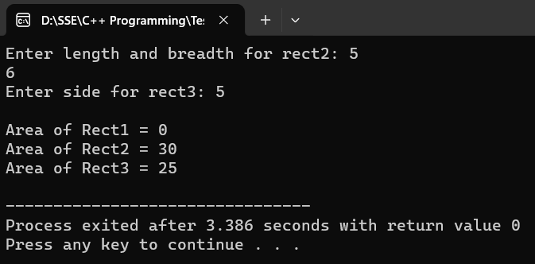

1. Number pattern

Program :

#include<iostream>

using namespace std;

int main()

{

int i,j,n;

cout << "Enter the number of lines : ";

cin >> n;

for (i=0;i<n;i++)

{

for (j=0;j<=i;j++)

{

cout << "1 ";

}

cout << "\n";

}

return 0;

}

Output :

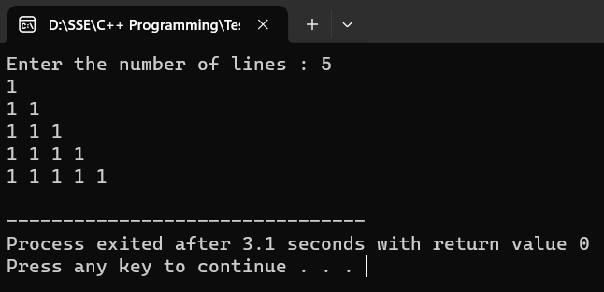

1. Create a class with Person (name age city). Derive a class Student(roll_no array of subjects) function to sum of all marks,average and display all details.

Program :

#include<iostream>

#include<string>

using namespace std;

class Person {

public:

string name;

int age;

string city;

void get()

{

cout << "Enter name : ";

cin >> name;

cout << "Enter age : ";

cin >> age;

cout << "Enter city : ";

cin >> city;

}

void set()

{

cout << "Name : " << name << endl;

cout << "Age : " << age << endl;

cout << "City : " << city << endl;

}

};

class Student: public Person {

public:

int roll;

int subject[5];

void get()

{

Person::get();

cout << "Enter Roll number : ";

cin >> roll;

cout << "Enter 5 subject marks : " << endl;

for (int i=0;i<5;i++)

{

cout << "Subject " << i+1 << " - ";

cin >> subject[i];

}

}

void set()

{

Person::set();

cout << "Roll number : " << roll << endl;

int sum = 0;

double avg;

for (int i=0;i<5;i++)

{

sum += subject[i];

}

avg = sum/5;

cout << "Sum : " << sum << endl;

cout << "Average : " << avg << endl;

}

};

int main()

{

Person person;

Student student;

student.get();

cout << "\nStudent Details : " << endl;

student.set();

return 0;

}

Output :

